OSTEOPOROSIS is low bone mass and structural deterioration leading to bone fragility and increased risk of fragility fracture.
But, there are other things than BMD which contribute to fracture risk ( falling etc).

Role of GP.
- Recognise risk – of reduced BMD and of falls.
- Inform.
- Investigate.
- Treat / prevent.
- Refer.
- Review.

Remember physiology….
Peak bone 25-30y.
Lamellar bone / cortical bone.
Osteoclasts / osteoblasts.
Vit D / Ca++.
PTH / Calcitonin.
Primary / secondary osteoporosis.

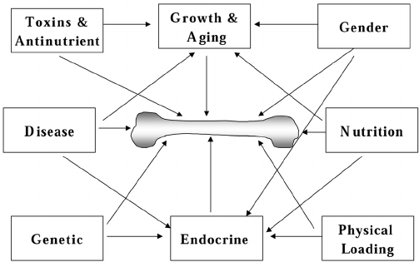

How to assess
- Clinical judgement.
- FRAX.
- DXA/ LVA

1.Clinical judgement
- the following are not included in FRAX but should make you consider BMD assessment.
- Postmenopausal.
- Thoracic kyphosis
- Height loss (> 4cm)
- Falls and frailty !!!
- Inflammatory disease: SLE, RA, CTD, Ank Spond etc
- Endocrine disease: T1DM ,T2DM, hyperparathyroidism, hyperthyroidism, hypogonadism, Cushing’s disease/syndrome
- Haematological disorders/malignancy- multiple myeloma, thalassaemia
- Muscle disease: myositis, myopathies and dystrophies, sarcopenia
- Lung disease :asthma, cystic fibrosis, chronic obstructive pulmonary disease
- HIV
- Neurological/psychiatric disease: PD, MS, epilepsy, stroke, depression, dementia
- Nutritional deficiencies: calcium, vitamin D [note that vitamin D deficiency causes fracture risk through undermineralisation of bone (osteomalacia) rather than osteoporosis]
- Bariatric surgery and other conditions associated with intestinal malabsorption (coeliac).
Excess l-thyroxine. Patients with thyroid cancer with suppressed TSH are at particular risk.
Drugs affecting gonadal hormone production (aromatase inhibitors, androgen deprivation therapy, medroxyprogesterone acetate, gonadotrophin hormone releasing agonists, gonadotrophin hormone receptor antagonists).
Some antiepileptics (eg. phenytoin and carbamazepine)
2. FRAX.
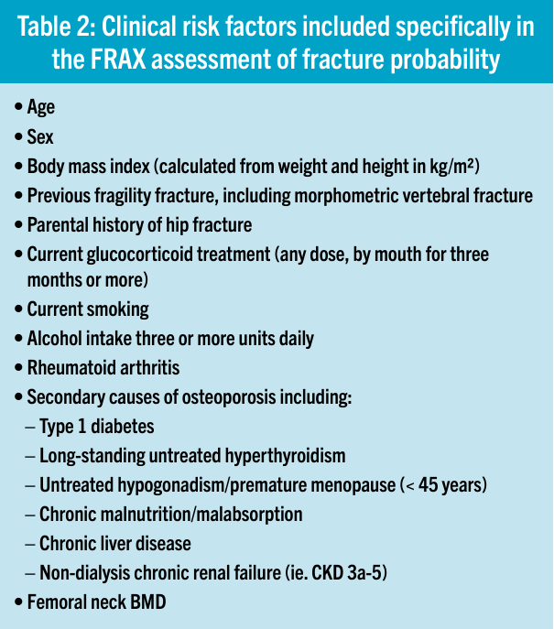
Give 10 year probability of major osteoporotic fracture (MOF).

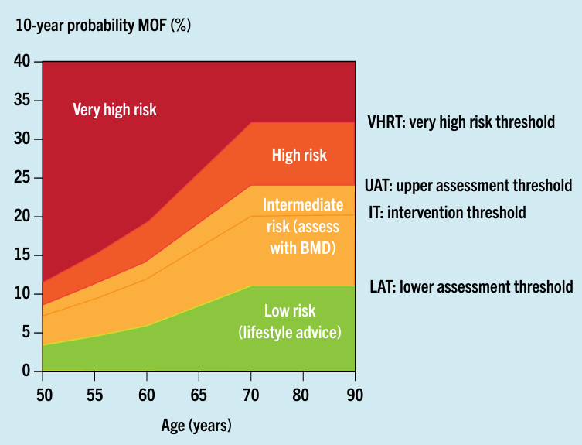
Treatment decisions are based on whether they fall above or below the intervention threshold identified for their age.
Ex:For those aged ≥ 70 years, the intervention threshold is set at 20% probability of major osteoporotic fracture.
Using clinical consideration and FRAX may avoid need for DXA.

3.DXA.
Gold standard.
But half of fractures occur in those who do not have osteoporosis.
Femur more representative as Vertebrae can have collapse causing apparent density.
Both are checked.
BMD given as T and Z score.
For comparisons use same machine.
Use “worst” score.
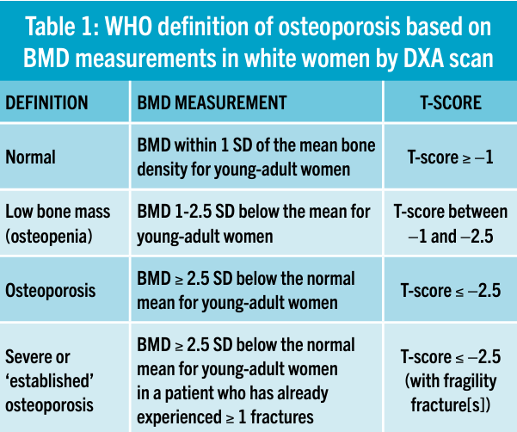

LVA – often done with DXA.
Recommended in those with ≥ 4cm height loss, kyphosis, glucocorticoid therapy, BMD ≤ -2.5, or those with acute back pain + risks for osteoporosis.
Checks for vertebral fracture.

Other tests – often to r/o secondary causes.
- FBC.
- Renal, live, bone.
- TFTs.
- PTH.
- Vit D level.
- ESR /CRP.
- Coeliac screen.
- Myeloma screen.
- AI screen.
- Testosterone.

So, strengthen the bone and reduce the falls.
Non-pharmacological advice to all.
- Smoking cessation.
- <2 U alcohol / day.
- A healthy diet, with calcium of 800-1,200mg per day is recommended.
- Supplement with Vit D as per HSE.
- Exercise – age specific guides available. Balance exercises v useful.
- Falls assessment including meds review, eyesight, trip hazards etc.

Pharmacology.
HRT if < 60.
Bisphosphonates. Alendronate 70mgs weekly. Review in 3m then every 12m. Osteonecrosis of jaw -rare. Atypical femur fractures -rare, duration dependant (esp > 8y). Benefits continue after stopping – drug holiday to reduce risk but continue benefit. Review at 5 years to see if staying on – use FRAX or DXA to assess. Max 10 years.
Denusomab. MAB. 10 years. Rapid wearing off so no drug holiday! Need to back fill. 6m. Check Ca++. 1 in 200 risk of hypocalcaemia.
Teriparatide – hospital , 2 years daily S/C injection of PTH.
Strontium.
SERMs.

Who might we need to refer?
- Recent vertebral fracture.
- History of two or more vertebral fractures at any time.
- BMD ≤ -3.5
- Ongoing treatment with glucocorticoids at a dose of ≥ 7.5mg per day.

